

Faculty of Engineering Sciences and Technology
Data Structure And Algorithm
CCP: Algorithm Visualizer
Streamlit
-

Instructor: Azziz Mehmood Farooqi
Members:
- ALI UR REHMAN 67267
- ZAINAB FAISAL 67550
- ANZILA KHAN 67265
- RAHUL KUMAR 67246

See Project Online: Link
Streamlit

1. Problem Understanding & Requirements Breakdown
The primary objective of this project is to analyze and compare the performance of various sorting and searching algorithms through simulation on large datasets (1000+ records). Additionally, the system supports full CRUD (Create, Read, Update, Delete) operations and visualizes algorithm efficiency using graphs.
Key Functional Requirements:
- Implement sorting algorithms: Bubble Sort, Quick Sort, Merge Sort.
- Implement searching algorithms: Linear Search, Binary Search.
- Visualize time complexity behavior with increasing input sizes.
- Allow record management (add, update, delete, view).
- Recommend the most efficient algorithm based on empirical data.

2. Data Structures Used & Justification
Data Structure | Purpose | Justification
List[Dict] | Store full records (each as a dictionary) | Simple to implement; flexible for CRUD operations.
List[int] | Used during search/sort testing | Efficient for indexing, slicing, and manipulation.
Dict | Represent individual record (e.g., {"id": 1, "name": "Ali", "age": 20}) | Direct attribute access by key makes record handling intuitive.
The combination of lists and dictionaries balances ease of implementation with operational efficiency.

3. Algorithms Implemented

Sorting Algorithms:
- Bubble Sort – Simple, educational, but inefficient for large datasets.
- Merge Sort – Stable and consistent with predictable performance.
- Quick Sort – Fast in practice but sensitive to input order without precautions.
Reason of choosing these algo was they are most used for beginners in initial understanding of data structure so we should have strong command on them that's why we wanted to work with them.

Searching Algorithms:
- Linear Search – Works on unsorted data but inefficient for large lists.
- Binary Search – Requires sorted data; very efficient for large inputs.

Test Conditions:
Each algorithm is tested on:
- Random data
- Sorted data (Best Case)
- Reversed data (Worst Case)

4. Dry-Run Example: Bubble Sort

1. Bubble Sort – [5, 3, 1]
- Pass 1: [5, 3, 1] → [3, 5, 1] → [3, 1, 5]
- Pass 2: [3, 1, 5] → [1, 3, 5]
- Pass 3: No swaps → Done
Result: [1, 3, 5]

2. Quick Sort – [5, 3, 1]
- Pivot: 1 → left: [], right: [5, 3]
- Pivot: 3 → left: [], right: [5]
Result: [1, 3, 5]

3. Merge Sort – [5, 3, 1]
- Split: [5], [3, 1] → [3], [1]
- Merge: [3, 1] → [1, 3]
- Merge: [5, 1, 3] → [1, 3, 5]
Result: [1, 3, 5]

4. Linear Search – [5, 3, 1], target = 3
- Step 1: 5 ❌
- Step 2: 3 ✅
Found at index 1

5. Binary Search – [1, 3, 5], target = 5
- Mid: index 1 → 3 ❌
- Mid: index 2 → 5 ✅
Found at index 2
.

5. Time Complexity Analysis
Algorithm | Best Case | Average Case | Worst Case
Bubble Sort | O(n) | O(n²) | O(n²)
Quick Sort | O(n log n) | O(n log n) | O(n²)
Merge Sort | O(n log n) | O(n log n) | O(n log n)
Linear Search | O(1) | O(n) | O(n)
Binary Search | O(1) | O(log n) | O(log n)

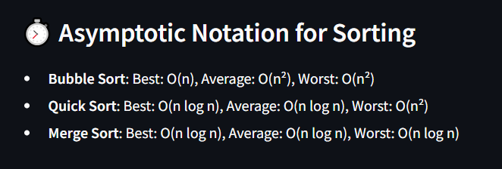


6. Graphical Representation
Note: Data is randomised so the graph will be different at the execution. We can check the best and worst case from the project online Streamlit:
6.1 Sorting Performance
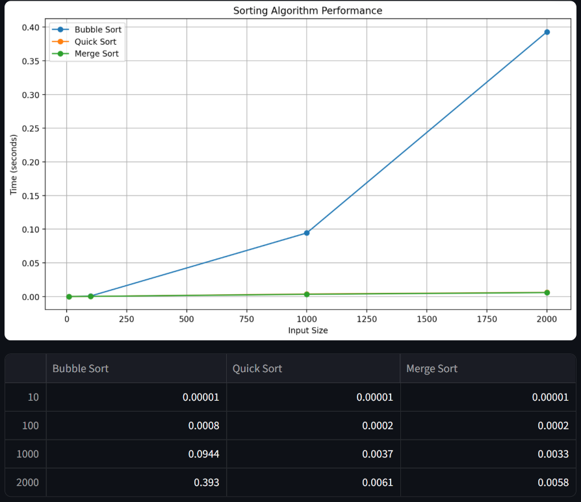
The blue spike shows the time the bubble sort took to sort the data. And since the time for sorting the data with other algorithms was so low we barely see any spike in them. In short, if the algorithm takes more time the graph will be upwards and if the algorithm takes less time the graph will be linear in the downward direction.
6.2 Searching Performance
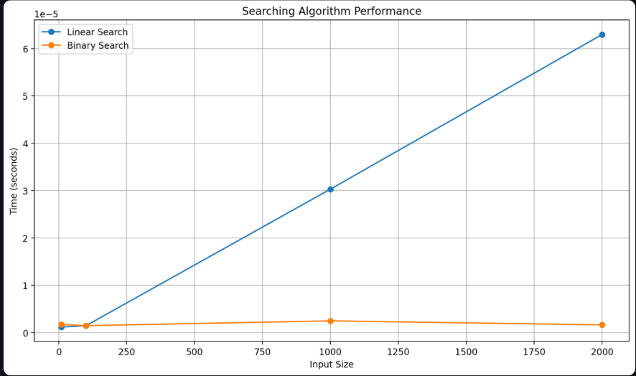
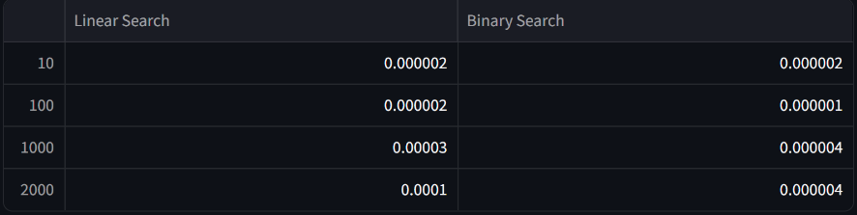
The blue spike shows the time the linear search took to search a random generated point from the data. If the algorithm takes more time the graph will be upwards and if the algorithm takes less time the graph will be linear in the downward direction.

7. Discussion of Limitations
- Quick Sort may raise RecursionError in Python with deeply sorted or reversed inputs unless recursion limits are handled. We continuously had to delt with this problem.
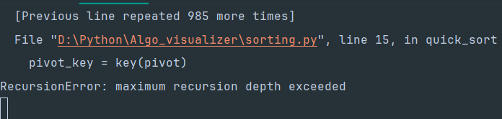
- Streamlit has deployment limitations when handling deep recursion or large in-memory datasets. But our project it was suitable
- No persistent storage: all records are held in-memory and lost on app shutdown or refresh.
- Bubble Sort is too slow for large datasets (O(n²) time).
- Quick Sort can cause recursion issues on sorted/reversed data.
- Merge Sort needs extra memory for merging.
- Binary Search only works on sorted data.
- Linear Search is inefficient for large lists.

8. Conclusion: Most Efficient Algorithm
Best Sorting Algorithm:
- Merge Sort consistently performs well across all data types, is stable, and suitable for larger datasets.
Best Searching Algorithm:
- Binary Search is optimal for sorted data due to logarithmic time complexity.
- Linear Search is suitable only when data isn't sorted or for small datasets.
Recommendation:
Use Merge Sort in combination with Binary Search for applications involving large datasets that require efficient processing.

9. Output
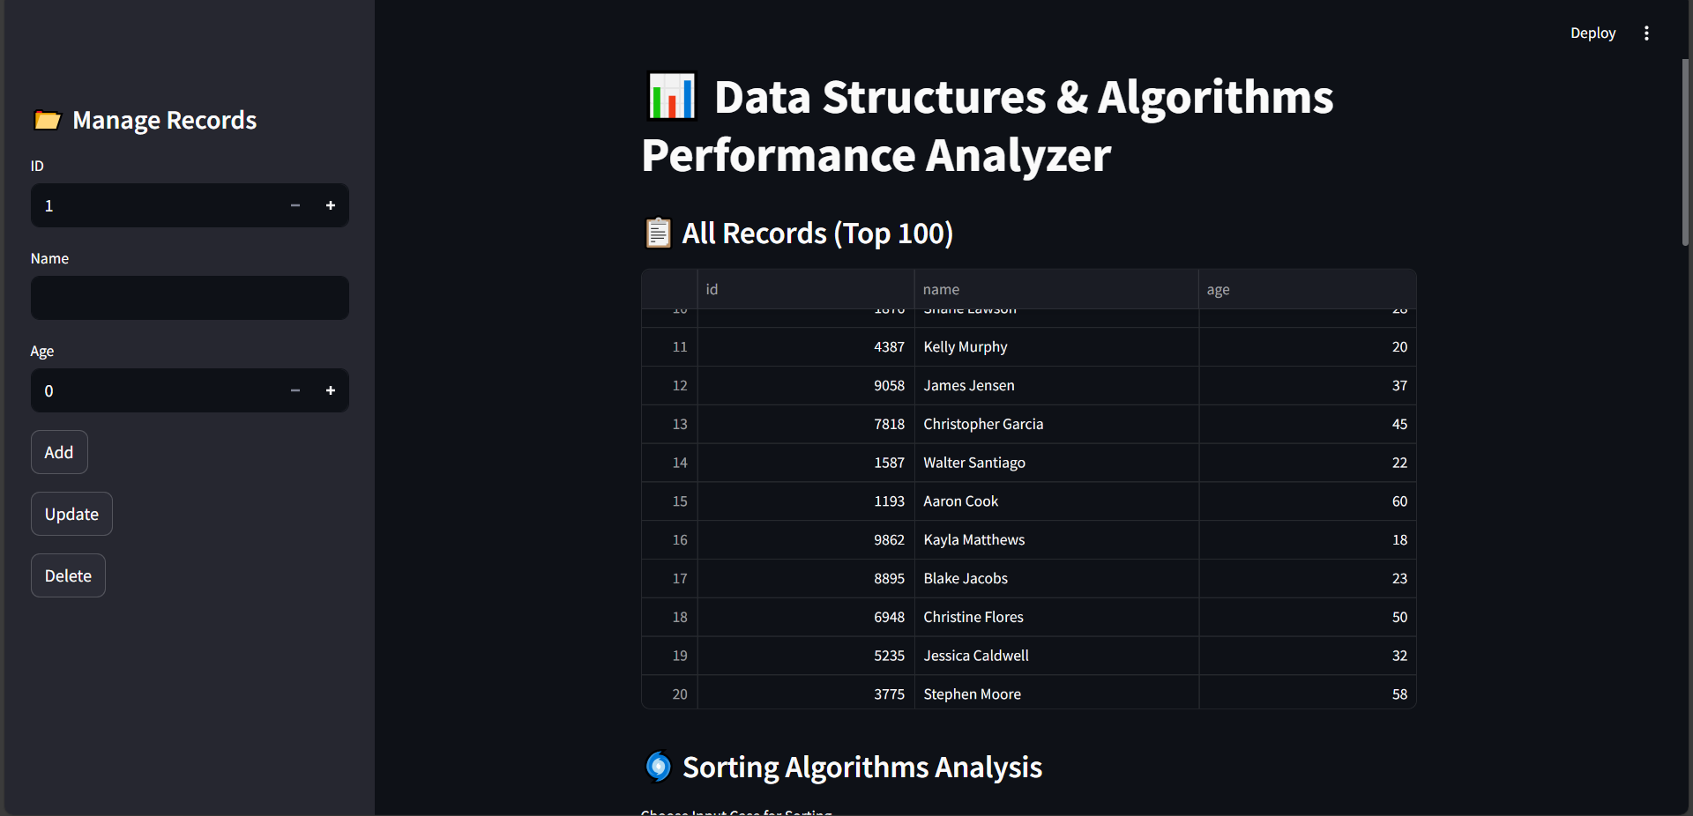

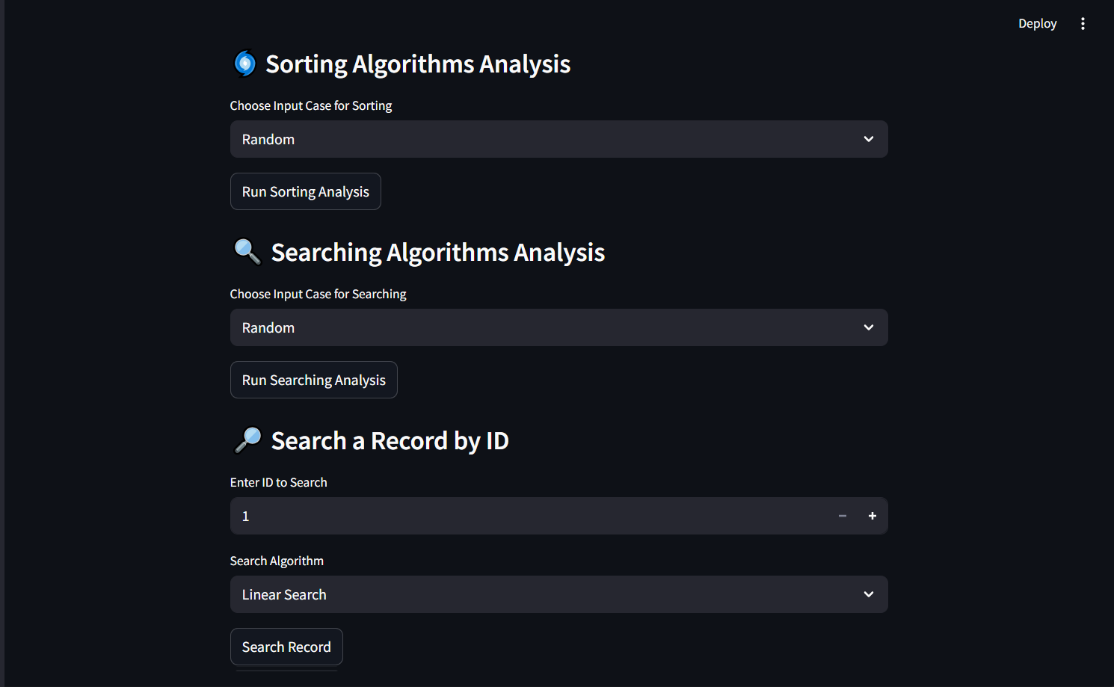
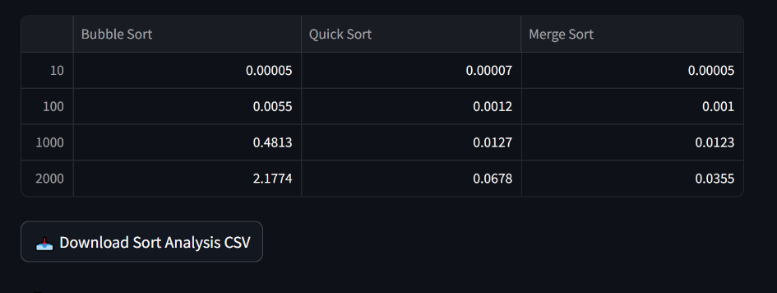

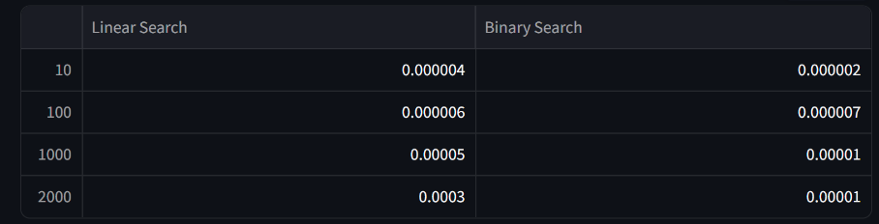


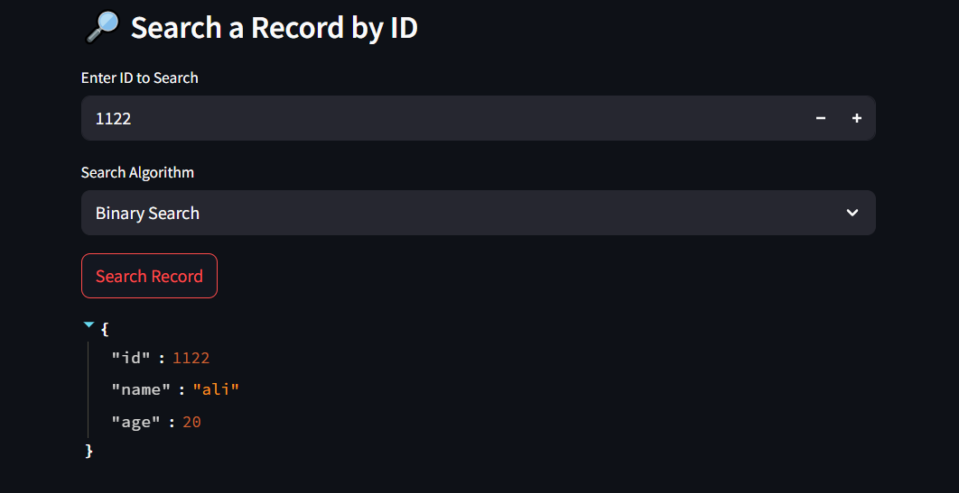


10. Code
main.py
import streamlit as st
import pandas as pd
from data_generator import generate_records
from crud import add_record, update_record, delete_record
from analysis import analyze_sort_algorithms, analyze_search_algorithms
from plot import plot_sorting_results, plot_searching_results
from sorting import bubble_sort, quick_sort, merge_sort
from searching import linear_search, binary_search

# --- Load Records
if "records" not in st.session_state:
st.session_state.records = generate_records(1000)

records = st.session_state.records

# --- Sidebar for CRUD
st.sidebar.title("📂 Manage Records")
id_input = st.sidebar.number_input("ID", min_value=1, step=1)
name_input = st.sidebar.text_input("Name")
age_input = st.sidebar.number_input("Age", min_value=0, max_value=120, step=1)

if st.sidebar.button("Add"):
new_record = {"id": id_input, "name": name_input, "age": age_input}
add_record(records, new_record)
st.success("✅ Record added!")

if st.sidebar.button("Update"):
updated_record = {"id": id_input, "name": name_input, "age": age_input}
if update_record(records, id_input, updated_record):
st.success("✅ Record updated!")
else:
st.error("❌ ID not found.")

if st.sidebar.button("Delete"):
if delete_record(records, id_input):
st.success("✅ Record deleted!")
else:
st.error("❌ ID not found.")

# --- Main Title
st.title("📊 Data Structures & Algorithms Performance Analyzer")

st.subheader("📋 All Records (Top 100)")
df = pd.DataFrame(records)
st.dataframe(df.head(100), use_container_width=True)

# --- Sorting Analysis
st.subheader("🌀 Sorting Algorithms Analysis")
sort_mode = st.selectbox("Choose Input Case for Sorting", ["Random", "Sorted (Best Case)", "Reversed (Worst Case)"])
if st.button("Run Sorting Analysis"):
sizes, sort_data = analyze_sort_algorithms(mode=sort_mode)
fig = plot_sorting_results(sizes, sort_data)
st.pyplot(fig)

df_sort = pd.DataFrame(sort_data, index=sizes)
st.dataframe(df_sort)
st.download_button("📥 Download Sort Analysis CSV", df_sort.to_csv(), file_name="sorting_analysis.csv")

st.markdown("### ⏱️ Asymptotic Notation for Sorting")
st.markdown("""
- **Bubble Sort**: Best: O(n), Average: O(n²), Worst: O(n²)
- **Quick Sort**: Best: O(n log n), Average: O(n log n), Worst: O(n²)
- **Merge Sort**: Best: O(n log n), Average: O(n log n), Worst: O(n log n)
""")

# --- Searching Analysis
st.subheader("🔍 Searching Algorithms Analysis")
search_mode = st.selectbox("Choose Input Case for Searching", ["Random", "Sorted (Best Case)", "Reversed (Worst Case)"])
if st.button("Run Searching Analysis"):
sizes, search_data = analyze_search_algorithms(mode=search_mode)
fig = plot_searching_results(sizes, search_data)
st.pyplot(fig)

df_search = pd.DataFrame(search_data, index=sizes)
st.dataframe(df_search)
st.download_button("📥 Download Search Analysis CSV", df_search.to_csv(), file_name="searching_analysis.csv")

st.markdown("### ⏱️ Asymptotic Notation for Searching")
st.markdown("""
- **Linear Search**: Best: O(1), Average: O(n), Worst: O(n)
- **Binary Search**: Best: O(1), Average: O(log n), Worst: O(log n)
""")

# --- Search Individual Record
st.subheader("🔎 Search a Record by ID")
search_id = st.number_input("Enter ID to Search", min_value=1, step=1, key="search")
search_algo = st.selectbox("Search Algorithm", ["Linear Search", "Binary Search"], key="search_algo")
if st.button("Search Record"):
sorted_records = sorted(records, key=lambda x: x['id'])
if search_algo == "Linear Search":
index = linear_search([r['id'] for r in records], search_id)
if index != -1:
st.write(records[index])
else:
st.warning("Not found.")
else:
index = binary_search([r['id'] for r in sorted_records], search_id)
if index != -1:
st.write(sorted_records[index])
else:
st.warning("Not found.")

# --- Sort Records
st.subheader("📑 Sort Records by Age")
sort_algo = st.selectbox("Sort Algorithm", ["Bubble Sort", "Quick Sort", "Merge Sort"], key="sort_algo")
if st.button("Sort Records"):
key_func = lambda x: x["age"]
if sort_algo == "Bubble Sort":
sorted_list = bubble_sort(records.copy(), key=key_func)
elif sort_algo == "Quick Sort":
sorted_list = quick_sort(records.copy(), key=key_func)
else:
sorted_list = merge_sort(records.copy(), key=key_func)

st.dataframe(pd.DataFrame(sorted_list).head(100), use_container_width=True)

sorting.py
def bubble_sort(data, key=lambda x: x):
data = data.copy()
n = len(data)
for i in range(n):
for j in range(0, n - i - 1):
if key(data[j]) > key(data[j + 1]):
data[j], data[j + 1] = data[j + 1], data[j]
return data

def quick_sort(data, key=lambda x: x):
if len(data) <= 1:
return data

pivot = data[len(data) // 2] # Middle pivot helps prevent worst-case
pivot_key = key(pivot)

lesser = [x for x in data if key(x) < pivot_key]
greater = [x for x in data if key(x) > pivot_key]
equal = [x for x in data if key(x) == pivot_key]

if len(lesser) == len(data) or len(greater) == len(data):
return data # Avoid infinite recursion on equal elements

return quick_sort(lesser, key) + equal + quick_sort(greater, key)

def merge_sort(data, key=lambda x: x):
if len(data) <= 1:
return data
mid = len(data) // 2
left = merge_sort(data[:mid], key)
right = merge_sort(data[mid:], key)
return merge(left, right, key)

def merge(left, right, key):
result = []
i = j = 0
while i < len(left) and j < len(right):
if key(left[i]) < key(right[j]):
result.append(left[i])
i += 1
else:
result.append(right[j])
j += 1
result.extend(left[i:])
result.extend(right[j:])
return result

searching.py
def binary_search(arr, target):
low = 0
high = len(arr) - 1

while low <= high:
mid = (low + high) // 2

if arr[mid] == target:
return mid
elif arr[mid] < target:
low = mid + 1
else:
high = mid - 1

return -1

def linear_search(arr, target):
for i in range(len(arr)):
if arr[i] == target:
return i
return -1

plot.py
import matplotlib.pyplot as plt

def plot_sorting_results(input_sizes, results):
fig, ax = plt.subplots(figsize=(10, 6))
for algo, times in results.items():
ax.plot(input_sizes, times, marker='o', label=algo)

ax.set_title("Sorting Algorithm Performance")
ax.set_xlabel("Input Size")
ax.set_ylabel("Time (seconds)")
ax.grid(True)
ax.legend()
fig.tight_layout()
return fig

def plot_searching_results(input_sizes, results):
fig, ax = plt.subplots(figsize=(10, 6))
for algo, times in results.items():
ax.plot(input_sizes, times, marker='o', label=algo)

ax.set_title("Searching Algorithm Performance")
ax.set_xlabel("Input Size")
ax.set_ylabel("Time (seconds)")
ax.grid(True)
ax.legend()
fig.tight_layout()
return fig

data_generator.py

from faker import Faker
import random

fake = Faker()

def generate_records(n=1000):
records = []
for _ in range(n):
record = {
"id": random.randint(1000, 9999),
"name": fake.name(),
"age": random.randint(18, 60)
}
records.append(record)
return records

crud.py

def add_record(records, new_record):
records.append(new_record)

def update_record(records, record_id, updated_record):
for i, rec in enumerate(records):
if rec['id'] == record_id:
records[i] = updated_record
return True
return False

def delete_record(records, record_id):
for i, rec in enumerate(records):
if rec['id'] == record_id:
del records[i]
return True
return False

analysis.py

import random
import time
from sorting import bubble_sort, quick_sort, merge_sort
from searching import linear_search, binary_search

def measure_sort_time(algorithm, data):
data = data.copy()
start = time.perf_counter()
algorithm(data)
end = time.perf_counter()
return end - start

def measure_search_time(algorithm, data, target):
start = time.perf_counter()
algorithm(data, target)
end = time.perf_counter()
return end - start

def generate_data(size, mode="Random"):
if mode == "Sorted (Best Case)":
return [{"age": i} for i in range(size)]
elif mode == "Reversed (Worst Case)":
return [{"age": i} for i in range(size, 0, -1)]
else:
return [{"age": random.randint(0, 10000)} for _ in range(size)]

def analyze_sort_algorithms(mode="Random"):
input_sizes = [10, 100, 1000, 2000]
results = {
"Bubble Sort": [],
"Quick Sort": [],
"Merge Sort": []
}

for size in input_sizes:
data = generate_data(size, mode)
results["Bubble Sort"].append(measure_sort_time(lambda d: bubble_sort(d, key=lambda x: x["age"]), data))
results["Quick Sort"].append(measure_sort_time(lambda d: quick_sort(d, key=lambda x: x["age"]), data))
results["Merge Sort"].append(measure_sort_time(lambda d: merge_sort(d, key=lambda x: x["age"]), data))

return input_sizes, results

def analyze_search_algorithms(mode="Random"):
input_sizes = [10, 100, 1000, 2000]
results = {
"Linear Search": [],
"Binary Search": []
}

for size in input_sizes:
data = generate_data(size, mode)
data.sort(key=lambda x: x["age"])
target_record = random.choice(data)
target = target_record["age"]
age_list = [x["age"] for x in data]

results["Linear Search"].append(measure_search_time(linear_search, age_list, target))
results["Binary Search"].append(measure_search_time(binary_search, age_list, target))

return input_sizes, results

